2022 Class of 1960/1986 Recipients

September 6, 2022
Branford College

BRANFORD COLLEGE RECIPIENTS

STUDENT CLASS YR

Deirdre Flanagan…………………………………………………………………………………………………………23’

Sam Heimowitz……………………………………………………………………………………………………………23’

Laurel Humphreys……………………………………………………………………………………………………….23’

Julius Lin……………………………………………………………………………………………………………………..24’

Deirdre Flanagan
Amount of award: 2,000

Bio:
Deirdre Flanagan is from Chicago, Illinois and is double majoring in Neuroscience and History. She is a senior and planning to pursue medicine after graduation. Deirdre is also a part of the European Studies Concentration within the History major, and she is focusing her final project on the Lasting Legacy of the Irish War of Independence on the political attitudes of Irish people today. At Yale, she works as a copy editor at the Yale Historical Review, serves as the New Student Coordinator at St. Thomas More Catholic Center, and volunteers at the Connecticut Hospice. In her free time, she enjoys reading, golfing, and planning movie nights with her suitemates.

Summary:
During the fall semester of 2021, I took Professor Bonnie Weir’s seminar ‘War and Peace in Northern Ireland.’ This class introduced me to the three-decade long civil conflict within Northern Ireland known widely as the Troubles, and it helped me to explore the lasting political, economic, social, and health consequences within Northern Ireland. The class was unique in offering students the opportunity to ask questions of and speak with witnesses of the conflict through weekly Zoom interviews, which highlighted to me the power of first-hand accounts. Over the course of this class, I developed an idea for a final thesis project to explore more about the historical context for the conflict, the Troubles’ lasting political and social consequences within the Republic of Ireland, and the potential for future reunification of the North and the Republic.

Over this past summer, I was able to travel to Ireland to conduct research for my senior history thesis project ‘Political Attitudes in the Republic of Ireland: Past and Present’ thanks to the generosity of the classes of 1960 and 1986. The project began in County Dublin, where I performed archival research at the National Library of Ireland by analyzing newspaper clippings, handwritten letters, and typed historical reports relating to the Irish War of Independence. I then began to focus on and compare the wartime experiences of three specific counties in the South of the Republic: County Cork, County Kerry, and County Waterford. I analyzed local archives in each of these counties to explore the extent of their nationalist involvement. In each of these counties, I also conducted face-to-face interviews in which I began to investigate contemporary political attitudes towards Northern Ireland and reunification. I hypothesized that these contemporary attitudes are influenced primarily by one’s community and thus, would also be affected by one’s county’s historical involvement in the War of Independence.

A few key observations seem obvious from my work so far. Firstly, despite extremely close- proximity to each other, there does seem to be a historical difference in the wartime experiences of Counties Cork, Kerry, and Waterford during the Irish War of Independence. Based on the archives, it appears that these differences can be explained largely by the strength of local military leaders as well as the presence (or lack thereof) of English military officers within the county. However, in spite of such historical differences, there does not seem to be an overwhelming difference between the counties in terms of contemporary political attitudes towards reunification. In fact, interviewees across all three counties seemed to agree that historical justifications for a ‘United Ireland’ are becoming less and less important to younger generations.

Moving forward, I am excited to continue studying the effects of both the Irish War of Independence and the Troubles on life in the Republic today. Although I conducted interviews with participants from a wide range of ages and socioeconomic backgrounds, I understand that my sample size was still relatively small. Thus, I plan to analyze secondary sources, such as books and movies on the topic, as well as larger surveys, during my upcoming semester in order to investigate my preliminary observations. Then, I can begin crafting a 30-page written project which will be completed in the spring. I want to thank the alumni and donors who made this idea possible and gave me the opportunity to engage with Irish people and texts in a close and meaningful way.

Sam Heimowitz
Amount of Award: 4,000

Bio:
Sam Heimowitz (he/him/his) is a senior from Washington, D.C. pursuing a simultaneous BA/MA in East Asian Studies (China) and a BA in Russian, Eastern European, and Eurasian Studies (Eastern Europe & Eurasia). He is passionate about learning not only the most difficult languages in the world for native English speakers, but also those that are less-commonly taught and specifically non-Indo European, and one of his favorite things to do is to take classes with small numbers of students in them. At Yale, Sam is the co-president/creative director of Taps at Yale, the co-choreographer for Yale Steppin’ Out, a writer for Symposia, an active member of the East Asian Studies major student advisory committee and works as one of the lead Humanities and Arts Academic Strategies Peer Mentors. He has worked as a Branford Aide, been a co-chair for YMUN, taught for Splash, volunteered for City Step, and taught for YYGS in the past, and is on faculty at his home tap dance studio. Sam has studied modern Chinese, literary Chinese, Hungarian, and Turkish while at Yale, and over the summer, completed research for his RSEE senior thesis in three countries in Central and Eastern Europe.
Summary:
This past summer, I traveled to Ljubljana, Budapest, and Warsaw primarily to conduct interviews in preparation for my RSEE senior essay, departing on May 20th and returning on August 19th, after 90 days in Europe for the first time. I researched the LGBTQ movement in each region, focusing on how they began, how they developed, what the major changes over the past 30 years have been, and if there are any transnational connections between each country’s movement. I spent three weeks in Slovenia, nine weeks in Hungary, and four days in Poland, and left with 100s of historical pictures and 1000s more of my own, 36 interview recordings, and contacts with activists and scholars. I received guidance from two of my previous professors—one from Slovenia, and the other from Poland—and a visiting scholar from Hungary, all who have taught at Yale in the RSEE department prior to my departure.
With the help of Professor Mitja Velikonja, I was initially put in contact with Ljubljana Pride (the director and volunteer coordinator) as well as his sister, one of the major lesbian activists in Slovenia, who helps run the Lesbian Library and Archive (where I spent a lot of time scanning documents). Because of my interview schedule (10 were in person and 5 were on Zoom, since a few of my contacts got COVID during my visit!), I had free time to volunteer with the European Solidarity Corps (ESC) volunteer cohort at Ljubljana Pride, learning about the inner workings of one of the many LGBTQ-focused NGOs in Slovenia. I also was introduced to young LGBTQ activists from Poland, Slovenia, Malta, Spain, Brazil, Portugal, the UK, Italy, France, and the Czech Republic, and made lots of international contacts and friendships through my time with them. I saw how activism takes place on a very small-scale, given Ljubljana’s size (everyone knows everyone), and I marched in the third row of the Pride Parade on June 11th along with the volunteers with the roughly 3000 other participants. When I was not volunteering or interviewing, I spent a lot of free time reading materials on the history of Yugoslav and post-socialist LGBTQ movements and social movements writ-large, helping to contextualize the work I was doing.
The interview process started out a bit bumpy; I did not know how much some people would be willing to share with me, and I soon realized that almost all of my Slovene contacts were only available during the last 10 days I was going to be in Ljubljana, making some of my time very tight (for example, I had three interviews, a Pride round-table discussion, and a 40 minute walk from my apartment all scheduled during one day in my third week). However, I quickly refined my questioning tactics, and the more people I talked to, the more comfortable I got with figuring out how to get the details that I wanted from my interviewees. Because Slovenia is so small, and because everyone truly does know everyone, I was able to talk to people who work in high-ranking positions in Parliament, the first man to get married under the Civil Partnerships Registration Act, and many people who had received national and international awards.
On June 12th, I traveled by bus to Budapest. The six-hour journey was a bit stressful, since not only had the cigarette smoke in Slovenia given me a really bad sinus infection, but my SIM card stopped working after the bus crossed the Hungarian border – if I had not used my Chinese skills with some Chinese-speaking tourists from the bus, I would have had a 6 mile walk to my apartment in the center of Budapest at 8pm! A similar situation soon presented itself like in Ljubljana; most of my interviewees were not going to be available for weeks, if not months! Luckily, with the gracious help of visiting postdoctoral associate Aniko Szucs, I secured a 5-week internship with Társaság a Szabadságjogokért, or the Hungarian Civil Liberties Union, and spent two days a week in-office, working on an English-language comparative elections in the European Union Report. I focused on Czechia, Slovakia, Slovenia, Poland, Romania, and Serbia, specifically looking into absentee and mail-by-post voting practices as well as ethnic and national minority party representation. Because of my interest in the Hungarian LGBTQ movement, my boss tried to find as many avenues for me to incorporate that into my work in the office as well. I attended a training with one of my colleagues to become a legal observer (jogi megfigyelő) at the Pride Parade (but ultimately did not serve as one because a) I did not have the same legal representation that the other observers did, and b) my plans were to be a participant-observer at Budapest Pride, as I had been at Ljubljana Pride), and I attended a roundtable on Polish and Hungarian anti-LGBTQ and anti-gender mobilization with that same colleague, which introduced me to around 4 new contacts.
When I was not in the office, I traversed Budapest, and found myself many times with the directors of Háttér Társaság (“Background Society”), the first and oldest LGBTQ NGO in Hungary, which hosts the only LGBTQ archive and library, akin to the library in Slovenia. There, I made copies of the founding documents of two now-defunct organizations, collected photographs from the first Pride parades, and interviewed 5 people, including the founder of the association. Through these interviews, I started to draw comparisons between life under Yugoslav socialism and life under Hungarian socialism, as well as the differences in the political responses to the LGBTQ movements’ efforts towards equality.
After 5 weeks, I began a 4-week Hungarian language intensive at ELTE, while continuing to interview more people (with varying degrees of English competency, which certainly pushed my language skills to the limit!) and attended Budapest Pride. Budapest Pride is exponentially bigger than Ljubljana Pride. I marched with two members of a countryside LGBTQ NGO, one of whom I had met in Ljubljana, braving the 106-degree heat with 35,000 other people. Right before this parade, in late July, Slovenia had just legalized same-sex marriage, and they were enjoying a relatively calmer status quo (the VP of Parliament is a lesbian, and the new Minister of Culture is a gay man, for example). I must also point out that far right and neofascist actors ripped up Pride posters and drew Celtic crosses on top of equality graffiti while I was in Ljubljana, and the most violent display of protest I had seen to date in Budapest was the scratching of the text on a rainbow sticker campaign against the anti-LGBTQ referendum earlier in the year. However, during the parade, the far-right Our Home political party (Mi Hazánk), illegally occupied the Margaret Bridge with a massive sign that said “STOP LMBTQ PROPAGANDA” (M = meleg = the Hungarian word for “gay”), and some other homophobic actors had set-up posters on Margaret Island and on little boats. There was no physical violence, since like in Slovenia, there was a massive police and law-enforcement presence, but this experience was the most direct confrontation I experienced while abroad.
Nonetheless, by the time I boarded the ten-hour bus from Budapest to Warsaw, I had interviewed 21 people, a mix on Zoom and mostly in person, with plans to interview at least three more once I returned to the US. Poland presented a few problems. I initially emailed 33 individual people from six different organizations and three universities. Seven responded, and two provided potential dates. The day before I left for Warsaw, the confirmed interviewee canceled without reason, and the other person who provided a time, did not answer my emails for confirmation. By the time I stepped foot in Poland, the young activist I had met in Ljubljana working with the ESC volunteers connected me with two of her friends, one of whom agreed to meet in person. Unfortunately, while Poland was the largest country on my list, I was only able to talk to one activist while there – which was still certainly useful – but not the most ideal situation. I had missed the Equality March since I was in Budapest, and many people were on vacation, so perhaps it was just a bad time to meet with activists, especially considering (and rightfully so) that so many organizations (including the LGBTQ ones) were preoccupied with the Ukrainian refugee crisis. This, however, is useful for my research: no answer is an answer in and of itself, underscoring the volatility of our current times and the unstable situation of LGBTQ rights in Poland. While Slovenia has been arguably making strides in LGBTQ rights in the past few years, Hungary has been slowly and quietly been stripping rights, and in Poland, people are still being targeted and some activists have been arrested, leading to the shut-down of a prominent NGO.
I left Warsaw the 18th and returned home on the 19th of August, having been in touch with over 15 NGOs, having met people from over 12 countries, having completed over 100 hours of interviews, having collected extensive research materials from the Slovene and Hungarian LGBTQ libraries and archives, having learned more about the political systems all over Europe, and having increased my Hungarian proficiency and confidence level exponentially. I made long-lasting connections with young people, professors, and educational institutions, and succeeded in fulfilling almost all of the goals I initially set out when I designed this project in February, combining my linguistic, regional, and sociocultural anthropological interests all into one jam-packed summer over 4300 miles away from home.
I am so incredibly grateful to have had these variegated and life-changing experiences which would have been impossible without this funding. Thank you to the Class of 1960 Fellowship Committee for your support. This project still has a long way to go – and perhaps could even be transformed into a post-graduate thesis, to continue more work in the region on the same issues.

Laurel Humphreys
Amount of award: 3,000

Bio:
Laurel Humphreys was born and raised in Tucson, AZ. She will be graduating in May 2023 with a degree in Ecology & Evolutionary Biology. Laurel’s senior research project is focused on the interactions between fungi and epiphytic bryophytes. She is one of the “Poobahs”, or student coordinators, of FOOT, the largest first-year orientation program at Yale. Laurel is also an artistic director for Yale Children’s Theater and has led workshops, performed, and written a play for youth in New Haven. She and her dog Fergus spend all their free time going on “sniffy walks” and finding exciting rocks, plants, and smells.

Summary:
On a warm day in early July, I pulled a banana sandwich out of the pouch on my hip.
With one booted heel hooked onto a branch, I swayed with the breeze, trying not to get
breadcrumbs on my climbing gloves. A thick red rope held me up in the bigleaf maple. Buried in
a thick mat of bryophytes, the rope seemed to disappear into the green up ahead. As I ate my
lunch between plots, I imagined a middle school version of me watching myself from forty feet
below. I had no idea that being a scientist was an actual career the existed, let alone that I would
be one, harnessed up to a tree during a busy field season in Olympic National Park.
Half of my days looked exactly like that. Michelle Spicer, a postdoctoral fellow at Yale
and the University of Puget Sound, and Peter Lagemann, another undergraduate, and I would
drive from the Olympic Natural Resources Center to the Hoh Rainforest. We would spend an
hour or so pulling our climbing lines over that day’s bigleaf maple and anchoring them down to
the ground with a series of knots. Some days, it took more time, especially if we had to rethrow
our lines after a curious elk pulled them down with his antlers. After setting up, Michelle and I
would get into our harnesses, test out our ropes, then start climbing as far as the ropes would take us.

We spent five to six hours up in the canopy each day, doing cover estimates and point counts
of plots. HypSub is in one, two, four, and seven. Encroaching in nine. Probably about… hmm…
I’ll give it twelve percent. Then I would open my favorite pouch, the one that held my microbial
sampling materials, and take tiny little samples of nearby mosses and liverworts, for my own
research. Every other day, Peter would be the one in the canopy, and I would study the ground
plots, take lunch breaks with banana slugs, and fail to bargain with the clouds of mosquitos
around my head.

At the start of my summer, I set out to examine the diversity and composition of fungal
communities among epiphytic bryophytes across a vertical gradient in the tree canopy. I filled
241 sampling tubes and homogenized them with a jerry-rigged bead beater. In mid-July, we
climbed our last maple, and I flew over to New York with a backpack full of moss-filled tubes,
much to the dismay of TSA. I spent the next three weeks with Dr. Jane Lucas at the Cary
Institute of Ecosystem Studies, where her assistant Charlene showed me how to extract and
amplify the fungal DNA from my samples. Now, I sit back and wait for my sequencing data to
come in, which will take at least a couple of months. My project is still very much in-progress.
Nevertheless, my time both in the field and in the lab this summer affirmed my love for the
subject and increased it tenfold.

Living at the ONRC, then at the Cary Institute, gave me countless opportunities to hear
from other researchers, lab managers, professors, and field technicians. These interactions have
opened my eyed to the myriad ways that I can continue engaging with research and science
communication after college, in graduate school, and beyond. After reading about tiny,
charismatic mosses and liverworts on my computer screen for months, finally getting to see them
with my own eyes and feel them between my fingertips was the experience of a lifetime, and I
could not be more excited to continue this project throughout my senior year at Yale. Thanks to
the Class of 1960/86 Fellowship, I have been able to engage with my environment and with my
life goals in novel ways.

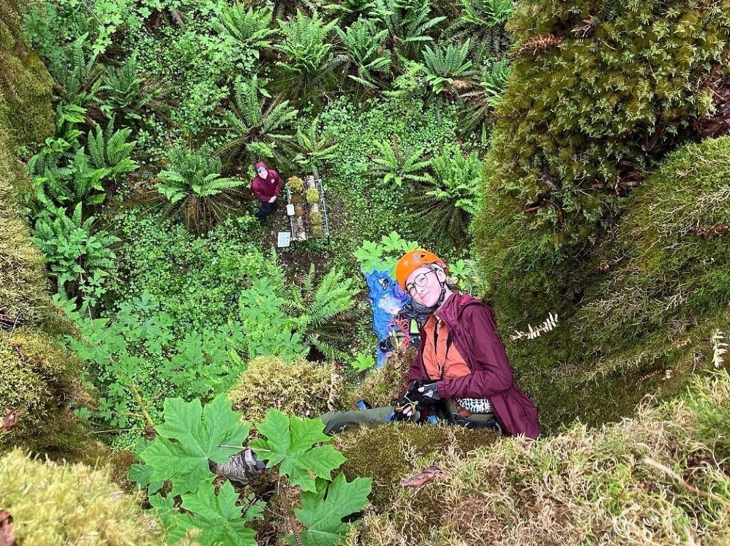

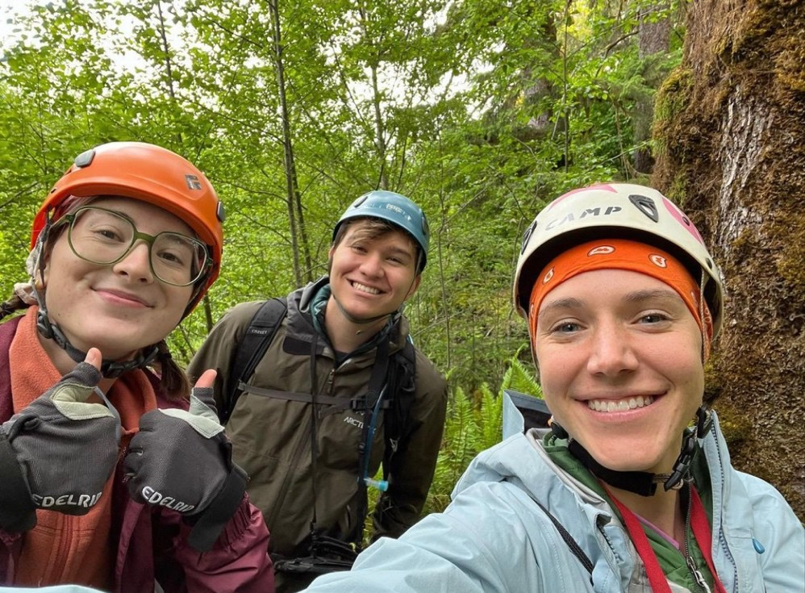

Julius Lin
Amount of award: 4,000

Bio:
Julius Lin was born in China and is double majoring in Classics, and Statistics and Data Science. He is always interested in exploring the intersection of backgrounds and disciplines, having published a paper on Yale Undergraduate Research Journal, titled Roman Serography, where he studied the writing of ancient Chinese people in Roman literature. Outside the classroom, he is involved with the University Church and volunteers in a variety of other venues. You will often find him in second-hand bookstores, scavenging a good read.

Summary:
Thanks to funding from the Class of 1960/86 Fellowship Award, I undertook my five-week archaeology field school in the ancient city of Gabii in Rome, tutored by renowned archaeologists from Yale and other institutions. The program lasted from June 19 to July 22, during which I started with little prior knowledge of archaeology and became, by the end of the program, acquainted with not only basic archaeological techniques, including the appropriate use of trowel, shovel, pickaxe, among other things, but also with the changing landscape of Gabii, which built upon my study of Roman history.
Surprisingly, the first and perhaps the most important lesson of field school was getting de-sensitized to finds. Broken pottery and tiles that one ordinarily only sees in museums behind glass were so commonplace on site that many lesser ones were deemed not worth keeping. The storage and filing of the staggering abundance of materials, therefore, gave each of us an incredible amount of discretion, which was exhilarating and scary all at once. Indeed, this discretionary power to decide what is and is not important shows why representation of different backgrounds matters in archaeology and other disciplines that concern humanity’s cultural heritage.
There is no question, however, that the rigor of physical labor in the field school posed a substantial challenge to me, and, according to my observation, most other first-time participants. On most weekdays, we started at 8 A.M. and ended not until 4 P.M., with a brief cookie break and a longer lunch break in between. This means we effectively worked about six hours under the unrelenting heat of Rome each day, compounded by extreme weather this summer. Even if I do not pursue archaeology any further, this experience has taught me persistence and endurance, and it made me a stronger person in spirit, for which I will always be grateful.

